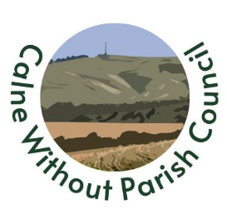
Email: CCNPAdmin@Calne.gov.uk
We take your privacy seriously and will only use your personal information to administer public consultation on the Calne Community Neighbourhood Plan 2 and to provide the information you have requested from us.

What we need:
Name, email or postal address

Why we need it:
If survey respondents require responses to their comments as part of the Neighbourhood Plan Regulation 14 Consultation, we require their contact details.

What we do with it:
We will hold the information securely to enable us to respond to comments.
The Neighbourhood Plan review is being undertaken as a joint enterprise by Calne Town Council and Calne Without Parish Council. Details may be shared with Wiltshire Council for the purposes associated with the Neighbourhood Plan
Other than this, we do not routinely share this information outside of our organisations but may share this information with our legal or trusted advisers for the purpose of obtaining advice, with government agencies if required by law, or with law enforcement agencies for the prevention or detection of crime.

How long we keep it:
Until the plan is ‘made’ or the end of 2025 whichever comes first. The data collected may be available in a report after this date but will be anonymised.

If you would like us to delete the information we hold or have any questions:
Please contact Calne Town Council 01249 814000 or email calne@calne.gov.uk

